**CSCI 360 Compare Instructions and Branching**

**Compare Instructions**

RX Format: label C R,D(X,B)

- Compares the fullword in R with the fullword at D(X,B)

Sets the Condition Code

Code Meaning

0 Equality

1 Fullword in R is less than fullword at D(X,B)

2 Fullword in R is greater than fullword at D(X,B)

RR Format: label CR R1,R2

- Compares the value in R1 to the value in R2

Sets the Condition Code

Code Meaning

0 Equality

1 Contents of R1 is less than the contents of R2

2 Contents of R1 is greater than the contents of R2

**Branching**

**Conditional Branch**

- used to alter the flow of program execution depending on the condition code set by an instruction

RR Format: label BCR B'*mask*',R

- **mask** is a 4 bit binary mask indicating which condition code(s) to branch on

- **R** is the register with the address to which to branch

RX Format: label BC B'*mask*',D(X,B)

- **mask** is a 4 bit binary mask indicating which condition code(s) to branch on

- **D(X,B)** is the address to which to branch

B'*mask*' ==> B'*bbbb*'==> B'*0123*'

where *0123* represent the possible condition codes

If b is 1, branch to the address in R on this condition code.

If b is 0, do not branch.

**Examples**

AR 3,4

BC B'1000',HERE branch to label HERE if result of the addition is 0

SR 3,4

BC B'1100',THERE branch to label THERE if result is equal to 0 or less than 0

NOTE: Using the mask B'1111', makes an unconditional branch (it will always branch)

**Example Read Loop**

XREAD BUFFER,80 read first record in the file

LOOP1 BC B'0100',ENDLOOP1 branch to ENDLOOP1 if end-of-file is reached

.

. body of the loop: process the record

.

XREAD BUFFER,80 read the next record in the file

BC B'1111',LOOP1 branch back to LOOP to check for end-of-file

ENDLOOP1 and go on… label for continuation after reading all of the records

The following is the flowchart of a structured read loop used to read a file (or any input) that has an unknown number of records or is empty.

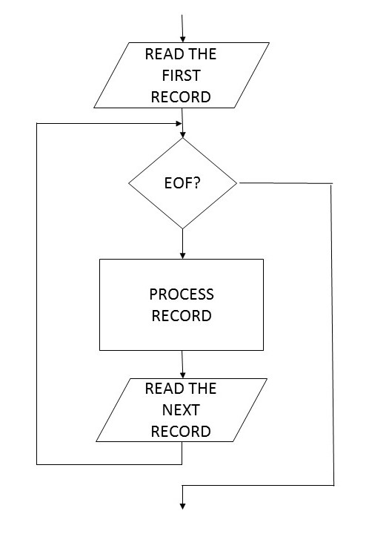

**Unconditional Branch**

Branches to a specific address no matter what the condition code is.

RX Format: B D(X,B)

- Branches to D(X,B)

RR Format: BR R

- Branches to the address in R

Now, with the condition code and branching, we can write decision structures (IFs) and repetition structures (LOOPs).